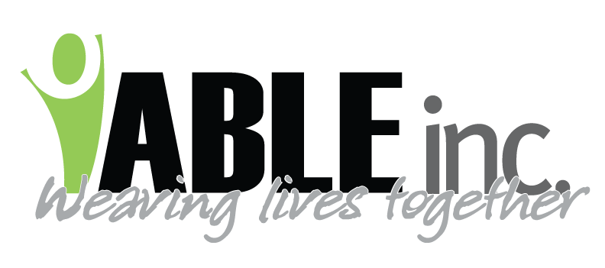

June 8, 2020

To our very exceptional families and guardians,

This is to give you a rundown of the latest data:
- Adams County has had no positive cases
- Bowman County has had no positive cases (they show 1 positive case but it was someone whose address was Bowman County but lived elsewhere)
- Stark County has had one new case in the past 4 weeks
- ABLE, Inc. has had zero positives for people supported and 1 positive for staff (in March)
- The Governor has placed North Dakota in the GREEN level of risk which means there is low risk. BLUE level of risk is normal. We are not BLUE yet.

Since our last letter, we have:
- Opened our stores in Bowman and Dickinson; Repeat Outlet, ABLE Thrift Center and Decades.
- People that we support have and will be returning to jobs where businesses have reopened. This is very individualized and specific to the needs of each person.

Based on data above, the ABLE, Inc. Board of Directors have implemented these NEW plans:
- June 8th, as communicated last week, Day Supports will begin at 1951 1st West. Based upon new public policy provided by the State DD Division, we will be moving back to a social/rec model without any employment activities in this building, Employment will be as it has been with several processes moving to the T-Rex Plaza. Day Supports will be limited to people supported who are living in the community with family or other providers to create some level of containment during COVID-19.
- For the people who live in apartments, families will be able to take people supported home with them. We are attaching the same information sheet that we have sent to our employees. Basically, outdoor activities with limited numbers of people are still the best options. Obtaining food through drive through is better than sit downs in a restaurant.
- For people who are living in group homes, we will continue family visits within the group homes rather than people supported going to family homes. Please understand that in group homes, people share common space, therefore the risk of infectious diseases is higher. Several families of people living in the group setting express a lot of comfort with greater restrictions. Plans have also begun on integrating productive work with safe cautions in and out of the home for your loved one. Sarah Carlson and I will be arranging a call next week to discuss with families, what direction you wish us to take in terms of resuming some level of normalcy.

Regarding employees, we will continue to:
- Wear masks
- Screen for illnesses and contacts
- Disinfect on a routine basis
- Ask employees to self-isolate if they are sick, or if they have been in contact with a person who has symptoms or tests positive, or someone in the household have been in contact with a person who has symptoms or tests positive.

We have been getting calls from staff and from families anytime the Governor makes changes. I wanted to also take a moment to explain that ABLE, Inc. hears the same information, at the same time, as you hear it. Please know that our process has been sifting through the information with ABLE, Inc.’s management team, processing that information with ABLE, Inc.’s Board of Directors every Wednesday, and then we revisit with our management team the following day. This is why the communication to families is coming to you on Friday. IT IS A LOT TO PROCESS in a quick manner!
Thank you for understanding the timing and the deep concern we hold for all those we support and their families.

Thank you so much for all that you are doing to keep yourselves and your loved one SAFE and HEALTHY!

Sincerely,
Mary Anderson
Executive Director

