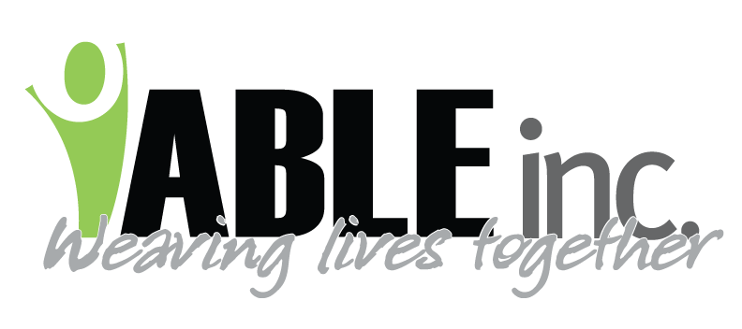
DATE: 6/7/2022
TO: ALL STAFF
SUBJECT: COVID UPDATES
FROM: KIRSTEN M. FRIEDT, RN-CDDN & MARY ANDERSON, EX. DIR.

Thank you for all you have done over the last 2 years to keep people safe from COVID. Unfortunately, we are seeing an increase once again to COVID infections in our region as well as across the state.
IT IS EXTREMELY IMPORTANT YOU CONTINUE TO SCREEN BOTH YOURSELVES AND PEOPLE SUPPORTED.
- PEOPLE SUPPORTED: check temps daily, preferable first thing in the morning when you are assisting them to get up/start their morning routine
  - As always, temperatures can be taken at any time if symptoms of illness are noted.
  - Report temperatures over 100.4 if taken orally, using a temporal scanning thermometer, or ear thermometer
  - Report temperatures over 101.4 if taken rectally
  - Report temperatures over 99.4 if taken under the arm.
- EMPLOYEES: Check temp upon arrival to your shift
  - Report temperatures over 100.4 if taken orally, using a temporal scanning thermometer, or ear thermometer
  - Report temperatures over 99.4 if taken under the arm.
  - IF YOU ARE AT HOME AND NOTICE SYMPTOMS of illness check your temperature, see above on when to report temperatures AND CALL THE COVID HOTLINE TO REPORT AND GET DIRECTION
- EMPLOYEE WITH SIGNS AND SYMPTOMS OF ILLNESS, REGARDLESS OF VACCINATION STATUS
  - Please continue to call with symptoms of illness, regardless of how minimal you think they are, when they are noted to help us determine if you should come in to work or if we need to find a replacement. The earlier you call the easier it is to fill your shift.
  - SIGNS & SYMPTOMS/WHEN TO CALL NURSING HOTLINE: 701-290-8565
    - Fever as above
    - Cough, shortness of breath
    - Congestion or runny nose
    - Body aches, extreme fatigue
    - Nausea, vomiting, diarrhea
    - Loss of taste or smell
- EMPLOYEE CLOSE CONTACT
  - Continue to call if you discover you are a close contact or household contact of someone with COVID.
- EMPLOYEE TESTING:
  - Anyone with symptoms continues to be asked to test for COVID and have negative results before returning to work.
  - SWDHU tests Monday through Friday 8am-10:00am.
  - Local clinics in Bowman, Hettinger, and Dickinson will also test for COVID.
  - Home tests are available at various locations, if you do a home test due to symptoms you must call the COVID hotline
  - If a home test is positive you must call the COVID hotline

