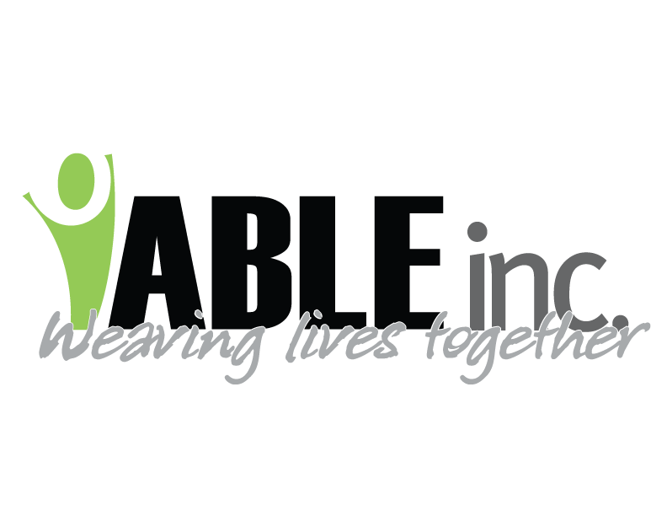

March 13, 2020

To ABLE, Inc. Employees:

We know some of you are concerned about the spread of COVID-19 (the new coronavirus) and how it may impact us at ABLE, Inc. Ensuring our staff and people supported are in a safe and healthy environment is our first priority.

The Centers for Disease Control and Prevention (CDC) have recommended a variety of steps that we are implementing to help reduce spread of the virus. However, we need your help. Below are some examples of how you can help protect yourselves and people supported, as well as prevent the spread throughout the community.

Please note that we have asked family members of people supported to refrain from “in-person” visits at this time. Should a family member contact you about visiting, please direct them to your residential manager or support coordinator.

1. Sick employees should stay home. At this time, we request that you stay home if you have any symptoms of respiratory illness. Those symptoms include: cough, fever, sore throat, runny nose, and/or shortness of breath.
2. Notify your Residential Manager or Support Coordinator if you develop respiratory symptoms while at work. These include: cough, fever, sore throat, runny nose, and/or shortness of breath.
3. We are asking you to be hypervigilant with practices of which you are already familiar such as; frequent and vigorous handwashing. (All employees should wash their hands for at least 20 seconds or use alcohol-based hand sanitizer that contains at least 60-95% alcohol upon entering the building and before and after interaction with people supported. Soap and water should be used preferentially if hands are visibly dirty.) Also cover your mouth and nose when coughing or sneezing, try not to touch your face and wear your gloves as trained.
4. Continue to perform routine environmental cleaning. Routinely clean all frequently touched surfaces in the workplace, such as workstations, countertops, and doorknobs. Use the cleaning agents that are usually used in these areas and follow the directions on the label. No special cleaning is necessary for COVID-19.
5. We are working with SWDHU on getting N-95 masks for staff should we have someone test positive. Your supervisor will let you know when your fit test will be completed for the N-95 mask.

ABLE, Inc. is following the recommendations of the CDC, NDDOH, SWDHU and other authorities. We will do our best to inform you of any changes should they occur. In the meantime, if you have any concerns or questions please contact your immediate supervisor.

Thank you for all you do to support people at ABLE, Inc.

Sincerely,

Mary Anderson

Executive Director