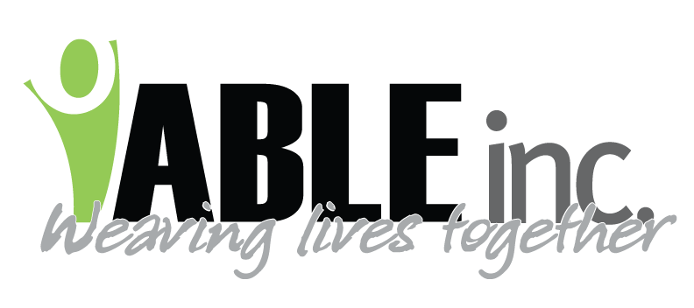
DATE: 4-13-2023
TO: ALL EMPLOYEES
SUBJECT: MASK USE
FROM: KIRSTEN M. FRIEDT, RN-CDDN

Effective immediately ABLE is returning to mask use and practices established in the memo from 3/15/2023. This protocol is attached to the current memo.

The rationale for our return:
- ABLE has not had a positive COVID infection since April 2, 2023.
- The COVID infection rates in all three counties where we provide support are low.
- Most who developed COVID in our latest outbreak had mild symptoms and quickly recovered from COVID.
- We still cover Shirley with our prayers as she makes slow steps forward in her recovery.

Quick Summary: (but please read and review the memo as well)
- Masks can be removed at this time from all sites except ICF
- ICF sites will continue with masks when with people supported, they can be removed when driving or out in the community. (per continued Board direction)
- Continue to call the nurse hotline with symptoms of COVID for further direction
- This may include testing, mask use, N-95 use, etc.

Please call with any questions or concerns regarding the memo.

