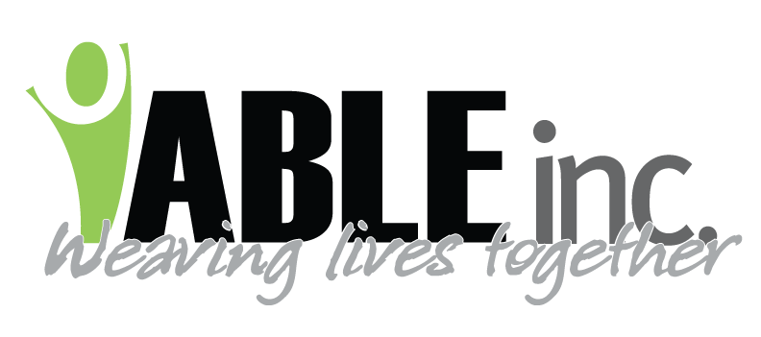 Leave Time During COVID-19
April 9, 2020
Dear Employees,
Below is information about how we are handling leave time during these uncertain times:
- Kirsten Friedt, ABLE Inc.’s Health Services Coordinator, is managing the nursing hotline.
- Kirsten uses the recommendations from the CDC, ND Department of Health and ABLE, Inc.’s best practices to determine if and for how long employees are to remain off work.
- For regular leave you must contact your supervisor per typical practice.
Leave Time Philosophy:
- Because people we support have fragile health conditions, we are being very cautious about employee’s health.
- During this time, knowing that there will be a lot of interruptions in the workplace, the Federal government has several unique programs to help both the employer and employee. For reduction of hours or extended illness, ABLE, Inc. may refer employees to ND Job Service. It is the responsibility of the employee to apply for unemployment and any correspondence needed per Job Service requests. ABLE, Inc. has no control on what benefits, if any will be paid out.
- We believe in the integrity of our employees and are trusting that they are calling with valid symptoms and concerns. However, there may be occasions when we require a physician’s order.
- We are working with each employee on a case by case basis. Nobody’s situation is the same.
Leave Time Practice:
- Employees are to follow the same leave policies for anything that is not related to COVID-19.
- ABLE, Inc. will evaluate LEAVE EACH pay period. Adjustments in this leave directive may happen if programs change or if our staffing needs change.
- If an employee experiences a reduction of hours, ABLE, Inc. may pay for those hours, refer the employee to apply for unemployment, or use a combination of both. NOTE: ABLE, Inc. considers Full-time to be 36 hours and Part-time what your schedule lists as your hours.
- If an employee has been screened to remain at home due to COVID-19, ABLE may pay for those hours, refer the employee to apply for unemployment, or use a combination of both.
- The leave that is granted for COVID-19 will not affect employees personal or extended leave. (This may be subject to change.)
- This leave practice will only extend through the COVID-19 crisis.
- For leave concerns related to COVID-19 that are NOT related to your own illness such as the loss of daycare, please contact a Director or Lead Support Coordinator.

Sincerely,
Mary Anderson
Executive Director

