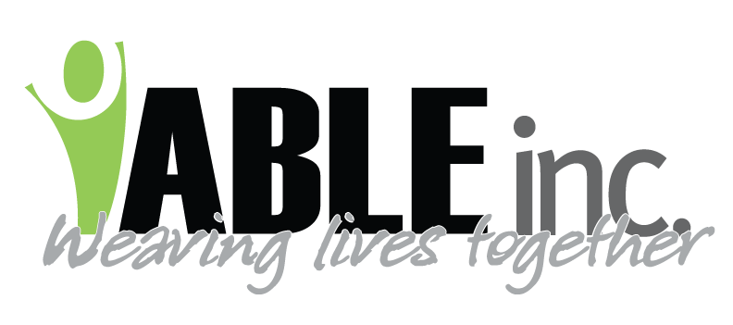
March 25, 2020
Dear Employees,
In the wake of the Coronavirus, ABLE, Inc.’s Board of Directors is extremely concerned for the people we support AND the employees who support them. As of March 19th, ABLE, Inc. Board of Directors are meeting weekly to monitor the situation. Employee physical health and financial health is a top priority.
ABLE, Inc.’s COVID-19 Plans as of March 25, 2020 include:
- IMPLEMENTED: 3-13-2020, ABLE, Inc.’s group homes were closed to visitor’s including families
- IMPLEMENTED 3-20-2020, ABLE, Inc. administrative building was closed to visitors
- IMPLEMENTED 3-24-2020, ABLE, Inc. Dickinson and Bowman’s Day Programs are closed to regular operations.
- IMPLEMENTED 3-18-20 increased scheduled disinfecting practices
- IMPLEMENTED 3-19-2020, employees screened via a checklist every shift prior to having contact with people supported.
- IMPLEMENTED 3-20-2020, started a nurse hotline to answer questions about symptoms and to screen for whether employees should remain at work.
- IMPLEMENTED 3-20-2020, started a nurse hotline to answer questions about symptoms for people supported.
For Our Employee’s physical and financial health
- IMPLEMENTED N-95 fit testing for employees beginning March 23, 2020
- IMPLEMENTED a practice where employees who have traveled internationally or out of ND will not return to work for 14 days beginning March 22, 2020.
- IMPLEMENTED reassignment for employees who are affected by closures and decreased hours by March 24, 2020. Done with the intent to reduce employee’s financial impact
URGENT NEW PLANS:
There are communities who are SHELTERING IN PLACE. We believe this is an excellent step for ABLE, Inc. employees due to the vulnerability of people we support and some employees. Beginning Wednesday, March 25th, we are respectfully asking our employees to:
- Remain at home when not at work unless it is essential
- Restrict visitors from coming to your home
- Contact a Lead Support Coordinator or a Director if you must travel. They can walk you through scenarios and precautions
We believe it is healthy to communicate with family via face time, skype, zoom, etc. We continue to encourage hiking, biking in remote areas or going for a drive. This directive will continue until national communications provide other information.
Mary Anderson
Executive Director

