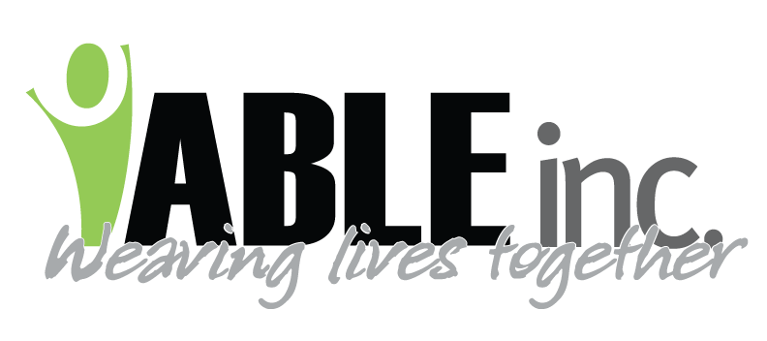
DATE: 2-7-22
TO: All Employees
SUBJECT: Mask Update
FROM: Kirsten Friedt

Dear Employees
Thank you so much for your cooperation regarding COVID. Using the N95 masks as you have is greatly appreciated. Friday, February 4th all who tested were negative! Based on our testing and local indicators, today, Feb 7th, 2022, we will be going back to using surgical masks rather than N-95’s (unless you have been specifically instructed to wear one based on nursing’s assessment).

Here is the plan:
- Surgical masks always while at work. Please use the surgical masks provided by ABLE. There is a difference in quality and effectiveness of masks. We ensure ours meet the standards recommended by the CDC.
- Continue to take your breaks one at a time and in a designated area.
- Continue testing twice a week in Dickinson, once a week in Bowman and Hettinger
- Regarding N-95 masks:
- We will continue fit testing all employees for a more available N95 mask.
- If you have been instructed to wear an N-95 mask, you must wear the one that you have been fit tested for and provided by ABLE, Inc. Fit testing insures that the mask has a good fit to protect you or the person supported.
- Using a N-95 mask directed by nursing could be for various reasons:
- When assisting with nebulizer treatments
- Symptomatic but testing negative
- When in close contact but testing negative
- When returning after COVID and finishing the full 10 days
- You have recently traveled where you would have been in a traveling hub such as airport, bus or train station, etc. or been to a large gathering.
- If there is an outbreak at your worksite or people who are unvaccinated need to be protected.
- If you feel you need to wear an N95 mask due to your personal situation.
- If employees have NOT tested during the week, they will wear a N-95 until a negative test result.

ABLE, Inc. continues to assess the local and national trends and follow guidelines set by the Department of Health and CDC.

Again, we thank you so much for all that you do to keep everyone safe. We look forward to the day when we can once again share smiles with everyone!

