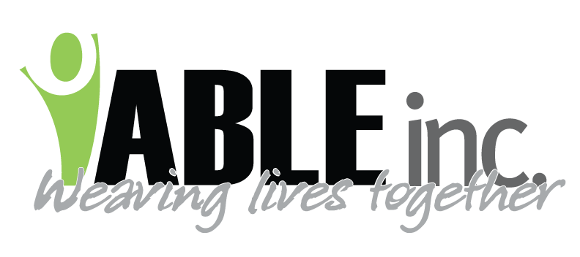
DATE: 8/26/2022
TO: ALL STAFF
SUBJECT: COVID TESTING
FROM: KIRSTEN M. FRIEDT, RN-CDDN

ABLE has suspended our weekly COVID testing until further notice.
Please remember to:
- continue with mask use while at work, including driving/riding in a vehicle with someone supported present.
  - It is ok to be outside with masks off.
- continue to do the screenings from temperature and symptoms prior to entering the workplace
- call the nurse hotline with any COVID symptoms regardless of if you are at work or home 701-290-8565
- call if you think/know you have been exposed to COVID
- test at other entities if you believe you may have COVID or have been exposed to COVID. These entities can include Southwestern District Health Unit in Dickinson M-F 8a-10am, or your local clinics
- practice good infection control measures such as cover your cough, disinfect surfaces at the worksite as we have been doing, report s/s of illness that people supported may be experiencing, continue with mask use, consider vaccination if you aren't already vaccinated
Thank you everyone for all your hard work on keeping people supported safe from COVID. I believe we have been doing a fantastic job keeping people safe and again, I thank each and every one of you.

Kirsten M. Friedt, RN-CDDN
Health Services Coordinator

