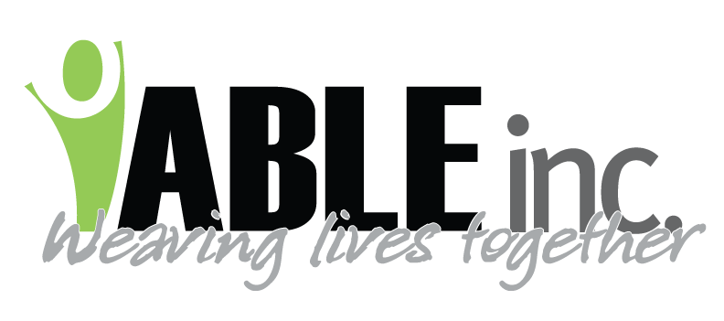

April 3, 2020

Regarding Coronavirus

Dear Employees,

It is hard to believe that we have had to alter our routines so drastically and quickly within the past few weeks. Coronavirus has us thinking deeply and carefully about everyone we meet and everything we touch.

Per CDC, the most vulnerable people are those who already have compromised health. This definitely includes the people we support at ABLE, Inc. Others around you might experience compromised health as well, your coworkers, your family members or even yourself. All in all, we must take precautions to protect one another.

Per CDC, person to person contact if the major source of transmission. This is why we sent the letter on March 25th, requesting that you:

- Limit travel to work and home; this includes ceasing your regular routines such as entering a gas station for a coffee, going shopping for unnecessary items, etc.
- Restrict people from coming into your home and refrain from going to other’s homes. You don’t know where they have been.
- Contact the ABLE, Inc. nursing hotline (701-290-8565) if you experience symptoms or have had contact with someone who shows symptoms.

Per CDC, it is unlikely that you will get Coronavirus from surfaces. However, this virus will live for hours to days on certain surfaces. Therefore, we are recommending that you take precautions:

Grocery store shopping:
- Go when there are fewer people
- Stay 6 feet away from people
- Wear gloves as a barrier. Regular gloves are better than nothing
- Put your groceries away
- Take gloves off
- Thoroughly wash your hands
Grocery store return:
- Wash raw fruits and vegetables in warm soapy water
- Let packaged containers such as boxed pasta sit for 24 hours
- Wash your hands

Fueling your vehicle:
- Put on gloves to fuel; regular gloves are better than nothing
- Pay at the pump
- If you must go inside, stay away from people, don’t make unnecessary purchases
- Leave promptly
- Don’t touch your face
- Wash your hands as soon as possible
When at work:
- Enter in one door for entering and leaving. Disinfect handles per house cleaning schedule
- Put gloves on when handling packages delivered to the home. Leave the package alone for a day. If you must open it, use gloves to open, remove gloves, remove contents, use gloves to throw the package
- Put gloves on when getting the mail, leave mail unopened until the next day
- Do not share computer or phones unless disinfecting between use
- Wash your clothes after work. Don’t re-wear them
- Consider the need to wipe off your shoes or leave them sit for a day
IF you MUST travel outside of home/work:
- Take gloves to apply when entering restrooms and other areas
- Take disinfectant wipes
- Take hand sanitizer as you may not have soap and water
- Keep the 6-foot distance rule
- Wipe down “drive through” containers
- Please communicate with your supervisor to review your trip plans to discuss cautions
- Discuss return trip with your supervisor, especially noting if you had any contact with a person with symptoms
Use your number one weapon….HAND WASHING

Thank you so much for caring about the people you support, their families, and your coworkers! Together we can be safe.

Mary Anderson
Executive Director

p.s. If you think of other tips and suggestions, please let me know. Or if you any
questions, please talk to your supervisor. Feel free to take a copy of this letter for
your own use.

